How to set up a Classroom Economy in your Chinese Classroom

- Create your own Class money or print the 熊猫钱.
- Buy or create your own rewards: ‘No Homework’ Cards, pencils, red envelopes, chopsticks, stamps, stickers, Chinese newspapers, fans, small books, printable mini-books, Note home to parents, White Rabbit candy, stamps, maps, photos etc.,
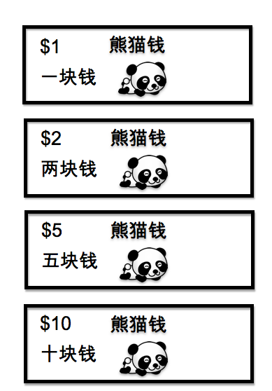
- Decide what you will give 熊猫钱 for：
Behavior:
- Great focus in class.
- No warnings.
- Quiet work.
Skills:
- Outstanding speaking skills
- Extra effort
- Consistent effort all week
- Improvement in writing skills
Character:
- Helps others
- Considerate toward others
- Excellent manners
- Persistence

Introduce the Classroom Economy to students.
- Make a wallet out of an envelope or colored paper.
- Name the wallet with student’s name.
- Explain to students it is their responsibility to care for the wallet.
- Every Friday, students will count their 熊猫钱 and record it on the front of the wallet.
- Explain to students how they will earn class money. Any student who asks for class money, will not receive any for one week.
- On the last day of the month, 2 store-keepers (students) will set up the class store with items for sale.
- Students may choose to save their 熊猫钱 or buy something from the store.
- When students buy something, they must count their class money using Chinese.

