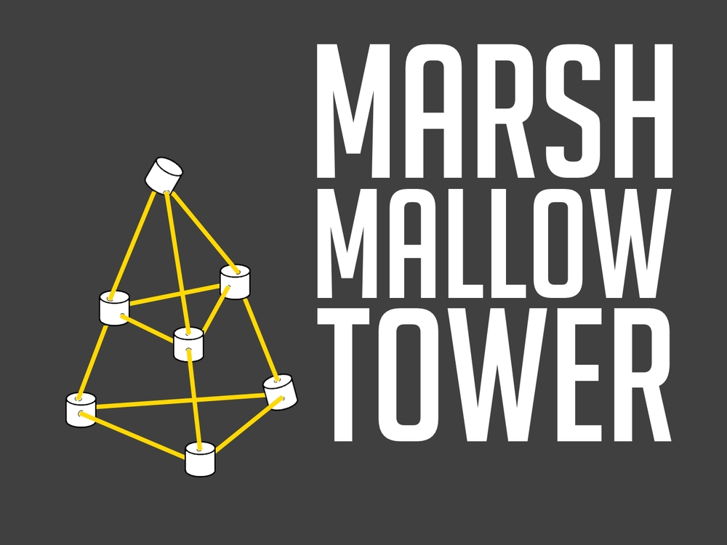
The Marshmallow Tower
Lesson Plan

Learning Outcomes

Students can:
- Work collaboratively to solve a problem.
- Use 一样，不一样，多，比，最 to compare objects.
- Apply the use of adjectives to descriptions: 可爱， 高， 矮，好

Connect
Discuss famous towers. Show images and ask students to recognize towers from around the world. Introduce 塔. ( measure word 座 )

Problem-solving Task
Introduce new words: 棉花糖， 面条，开始，
Tell students each group has 10 minutes to work together to build the tallest tower using spaghetti and marshmallow.
Introduce: 三角形 and 正方形 and ask students to think about how the tower will be built. Set a timer for 10 minutes. Ask students to begin. Teacher will walk around to each group, documenting use of language and collaboration skills.

New content
Using images, explain to students how to compare a tower: 高, 最，比，更
Encourage students to use the new vocabulary to compare their tower with another tower.

Application of new content
Print small Vocabulary Cards and give to students. Ask students to walk around the room and use the words to talk about the different towers created.

Consolidation Activity
Use the small Vocabulary Cards to compare themselves with another classmate – re-tall, short, hair, eyes, clothes etc.,

