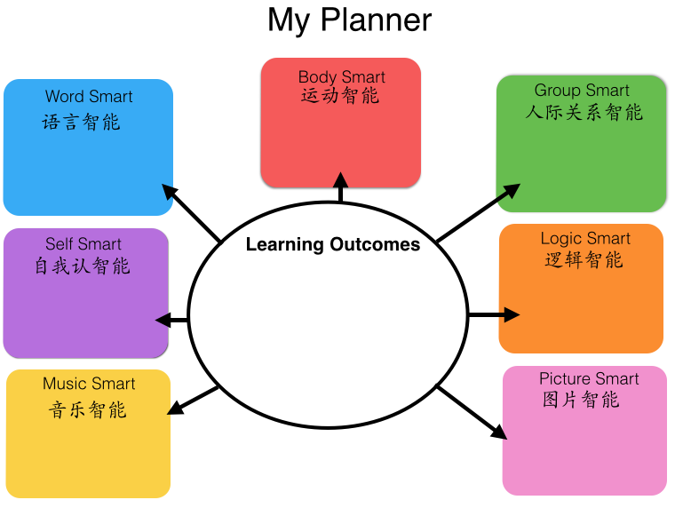
WhaWhat do we want our students to be able to do?

