Shapes and Food Lesson
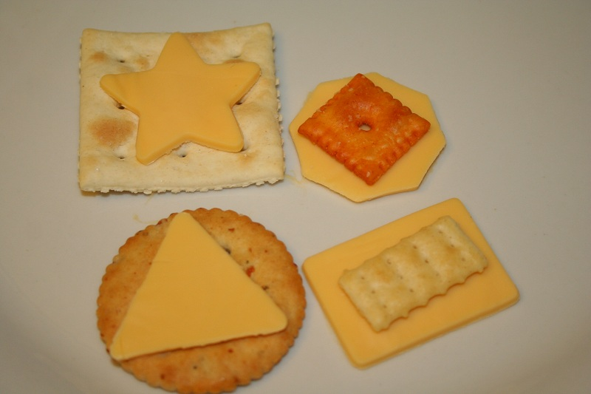
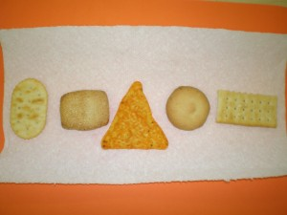
Give students a small plastic bag of food. Call out the shapes in Chinese. Students will find the correct shape and place it on the napkin. Continue until all shapes are sorted.

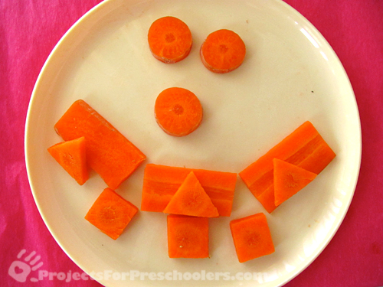
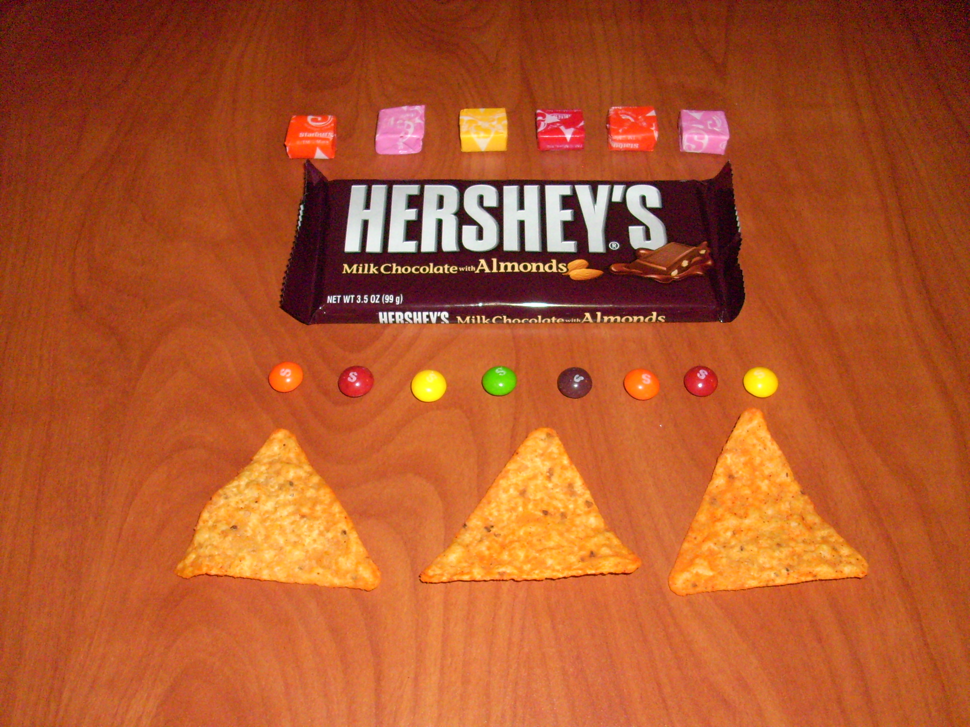
Shapes with carrots:

