Learning Outcomes – Week 3
Chinese

Name: _______________________________________________________________ Grade: ________________
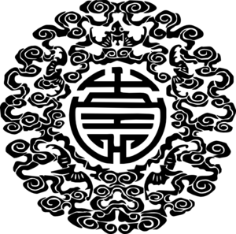
□ I understand the new ‘Let’s go to China’ and what is required at the end of the unit
□ I can listen and respond to Clothing vocabulary
□ I can match pinyin to pictures of clothing
□ I can role-play packing a suitcase with a Talk Partner
□ I can describe clothing using color words
□ I can label a photo using Chinese pinyin or characters
□ I can listen to clothing vocabulary and draw the appropriate clothing.

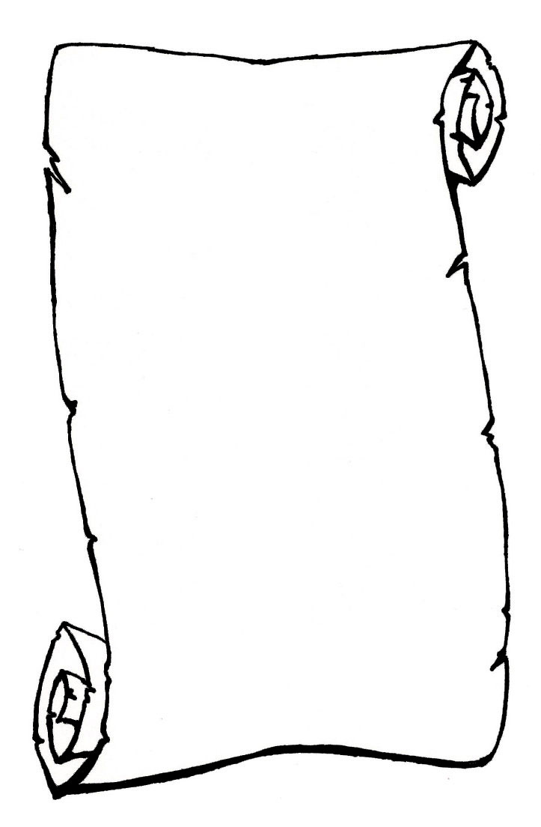
The most interesting part of Chinese class this week was:

New words I learned this week:

