Packing my Suitcase
Draw and label what you will take with you in your suitcase:
裙子  qúnzi | wŏ yào dài  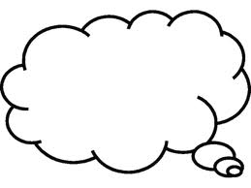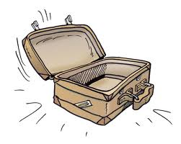
T 恤衫
T xùshān
短裤
duănkù
裤子
kùzi
紧身裤 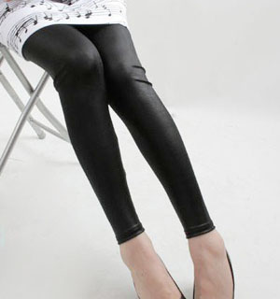
jĭnshénkù
凉鞋
liángxié
连衣裙
liányīqún
运动服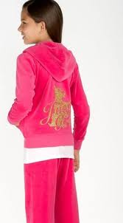
yùndòng fú

Packing to go to China!
Write in the characters for I want to take - 我要带。Draw and label what you will take with you in your suitcase:
裙子
qúnzi
T 恤衫
T xùshān
短裤
duănkù
裤子
kùzi
紧身裤
jĭnshénkù
凉鞋
liángxié
连衣裙
liányīqún
运动服
yùndòng fú

